Dear Parents/Carers,
The Reception team have recently sent you an email with a login for ‘Evidence Me’. This is a site that we use to share your child’s learning in school with you. It allows you to take photos, videos and can tell you in detail about what your child has completed during a specific activity.
You too can add observations and activities that your child has done during ‘Lockdown’. Over the next few weeks please try to add some observations to the site. Any learning your child has done, if they have been practising their numbers, or even if they are learning to ride a bike. All of this information can go onto this app/site with photo’s to build up ‘evidence’ of your child’s learning.
Please read the information below to help guide you with the site.
Take care, and be safe
The Reception Team

Evidence Me Parent App
The Evidence Me Parent App can be downloaded by clicking one of the above icons.

Download the App from your devices’ App Store

  - Visit the App Store or Play Store on your device and search for Evidence Me by 2Simple
  - Follow the steps to download the app
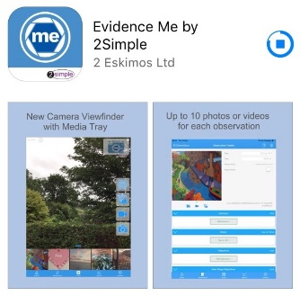

Log in to the app
  - Open the app on your device
  - Enter your Email and password
  - Tap Login
  - The following pop up message will appear:
    - “Evidence me” Would Like to Access the Camera – Tap OK
    - “Evidence me” Would Like to Access the Microphone – Tap OK
    - Would you like to save this password to use with apps and websites? Please Note: If you are using a shared iCloud account we would recommend clicking Not Now
    - Do you want to set a PIN? we recommend that you select OK to keep your app secure (you can select No and set this up at a later date).
  - Press OK

Create a Parent App Observation
For each Parent Share observation, you can add evidence. This could be an activity or a piece of work.
Tap on one of the below icons on the app Create screen to start your observation

Photo

  - The photo will be instantly captured
  - Edit your image using the image edit features – Please Note this feature will only appear if you have switched on Enable Crop Screen in the Settings area of the app
  - Tap Done in the bottom right-hand corner
  - Select Tap to Edit
TOP TIP: Your observation will automatically appear on your recent observations bar so you can always edit it at a later date.

Video

  - The video will automatically start recording
  - Click on the stop button to stop the recording
  - Click Tap to Edit
TOP TIP: Your observation will automatically appear on your recent observations bar so you can always edit it at a later date.
  - Click to amend the date and time (if required)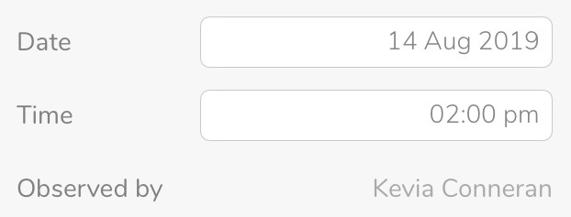
  - Tap on one of the icons below the image to upload more evidence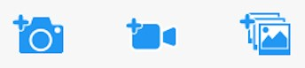

  - Tap Add Learners + – Please note a learner must be added in order for the observation to be sent to the school or setting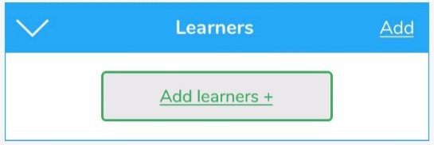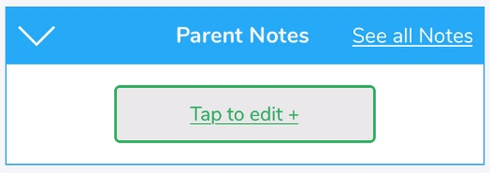
  - Tap Add Parent Notes +
Observations will automatically be uploaded to the school’s account as long as your device is connected to wifi. This is indicated by a green dot appearing in the top left-hand corner of the observation thumbnail.
Observations with a red dot in the top left-hand corner have not yet been uploaded and will upload as soon as your device is connected to a good wifi connection.

View App Observations
You will receive an email notification every time an observation is uploaded to the app for your child. By clicking on the link within the email notification you will automatically be taken to the new observation within your Evidence Me App.
You can view Parent Share observations at any time by opening the Evidence Me App and tapping Observations on the quick-access bar in the bottom left-hand corner.

Add Parent Notes
You can add notes/ comments to any observations by tapping Tap to edit + under the Parent Notes area of the observation. Type your note and click Back in the top left-hand corner for your notes to be automatically saved to the observation.
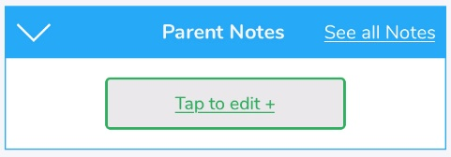

Parent Share Web Suite
Please visit evidence.me and log in with your username and password. We recommend that you use Google Chrome when accessing the web suite to ensure you have full access to all its features.

View Observations
From the Evidence Me home page, you can view all the latest observations.
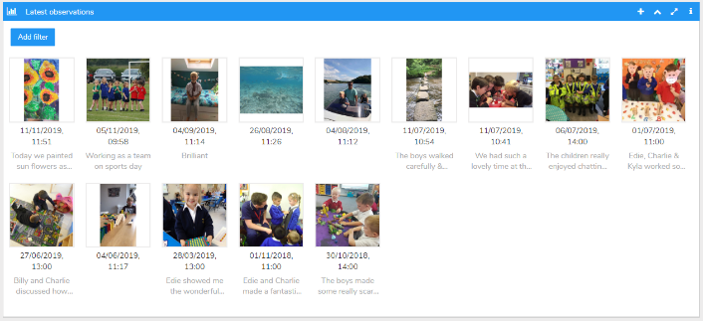

  - Click Add filter to view observations for a particular date.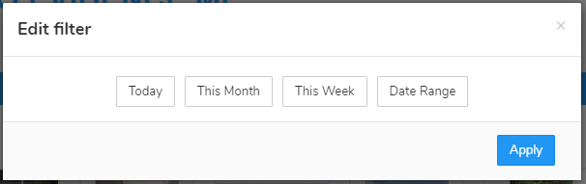

2.
Click on an observation image to view it.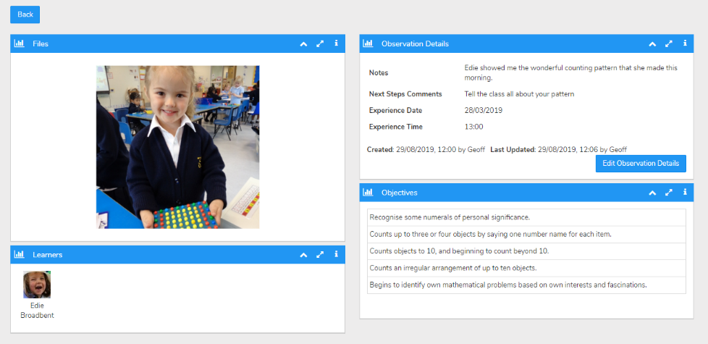
  - Click edit observation details to add Parent Notes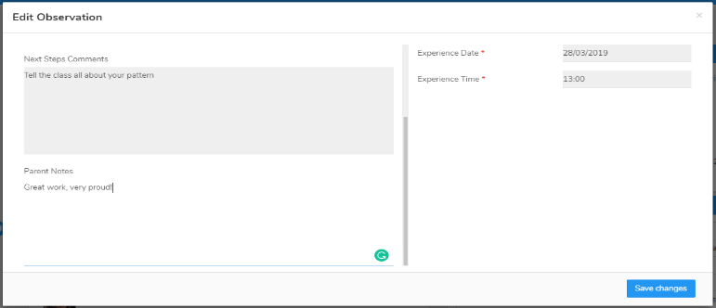

Create an Observation
Creating observations directly on the Web Suite is really quick and simple.

  - Click on the icon in the top right corner of the Latest Observations bar
  - Select your child/ children
  - Click Create an Observation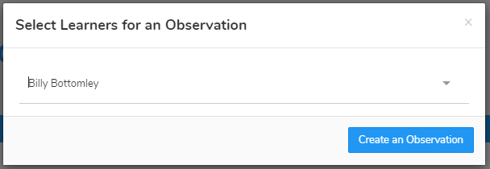
  - Click Upload in the top left-hand corner to add an image (photo/ video)
  - Upload your image by dragging & dropping it into the box or select Browse
  - Use the blue box to crop your image and click Add Image
  - Click Upload in the bottom right-hand corner
TOP TIPS:

  - To add more than one image re-click the Upload button
  - To delete an image click to highlight it, click on the bin icon in the top right-hand corner and click Delete

Your Parent Share observation will be automatically submitted to your child’s setting.

