Monday 11th January | P.E:  What you could do…  Try Pet Yoga - just try the cat poses today.  https://www.youtube.com/watch?v=s-Z127YfUQo | Phonics:  Sing Jolly Phonics songs  Phonics  Sing tricky words phase 2 on  YouTube  Sing Tricky words Phase 3 on  Youtube  Using your sounds can you spell these words. Dog, cat, map, bat, frog.  Challenge  Chip, church, buzz, dull, duck, chick. | English  Start off with a story!  Read ‘Jack and the Beanstalk ‘  http://www.communication4all.co.uk/http/Traditionaltales.htm  Make some puppets from the story.  Draw the characters, cut out and stick onto straws or lollipop sticks.  Retell the story using story language such as Once upon a Time. | Maths  Count forwards and backwards from any given number.  Make 3 beanstalks from play doh, lego or draw them.  Which is the tallest? How to you know?  Put the beanstalks in order tallest to shortest?  Tip: You can make play dough the day before.  https://www.bbcgoodfood.com/howto/guide/playdough-recipe | Handwriting:  Practise the letter join letters I, l, t.  You can use:  •Chalk outside  •Water and a paintbrush on the patio.  •Paint  •Use your finger to write the letters in a tray of flour.  • Use a whiteboard and white board pen.  Tip: Use letter join to help with joined up handwriting. There are lots of videos to help!  https://www.letterjoin.co.uk/log-in.html  Username: vt2910  Password: home
Tuesday 12th January | P.E:  What you could do…  Try Pet Yoga - try the dog poses today.  https://www.youtube.com/watch?v=s-Z127YfUQo  OR go for a walk. | Phonics:  Read one of your Bug Club Books.  Bug club  Log On:  Username:  Password: bug  School ID-7ach | English  On a piece of paper draw the Giant from Jack and the Beanstalk. Think of some words to describe the Giant and write them down.  Remember:  - To hold a pencil in the correct grip.  - To say the word aloud and write down the sounds you hear.  - Correct letter formation.  Example:  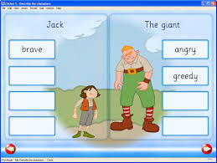 | Maths  Song: Count forwards and backwards from 20.  Hunt for plants inside and out.  Using a ruler, blocks or string measure the plants and record.  Which is the tallest plant you found? How do you know?  Challenge  Put members of your family in height order. Who is the tallest? Who is the shortest?  Remember to take a photograph and send it via Evidence Me. | Music:  Watch Debbie and Friends Jack and the Beanstalk to learn the story through singing.  Youtube  OR  Learn the song provided.
Wednesday 13th  January | P.E:  What you could do…  Try Pet Yoga - pick the one you like best to have another go at.  https://www.youtube.com/watch?v=s-Z127YfUQo | Phonics:  Sing Jolly Phonics songs on  Youtube  Sing tricky words phase 2 on  Youtube  Sing Tricky words Phase 3 on  Youtube.  If your child can do all the single sounds then introduce the ch digraph. Children to write down words with the ch sound.  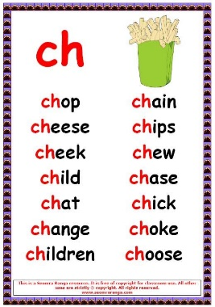 | English  Read the Story again  Read ‘Jack and the Beanstalk ‘  http://www.communication4all.co.uk/http/Traditionaltales.htm  On a piece of paper draw Jack from Jack and the Beanstalk. Think of some words to describe Jack and write them down. How many WOW words did you think of?  Remember:  - To hold a pencil in the correct grip.  - To say the word aloud and write down the sounds you hear.  - Correct letter formation. | Maths:  Count forwards and backwards to 20.  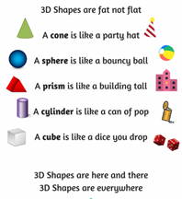Learn the 3D shapes song.  Singing Walrus on You Tube.  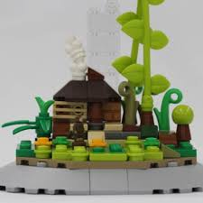  Make a Beanstalk and Castle from lego or whatever you have. How many bricks did you use?  Tell me about the different shapes?  Remember to send in a photograph via Evidence Me. | DT  Using boxes, you can make the Giants castle, a beanstalk or Jacks cottage.  What will you use to assemble your model?  Could you do a design first?  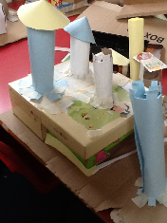
Thursday 14th January | P.E:  What you could do…  Today try Tallulah the Owlet | A Cosmic Kids Yoga Adventure!  https://www.youtube.com/watch?v=2aje33UPixE | Phonics:  How many words can you think of with the ch digraph.  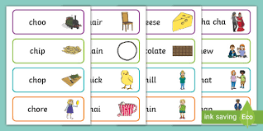  Draw a picture, write the word and add sound buttons.  Send a photograph on Evidence Me. | English  Imagine if you climbed up a Beanstalk and stood on a cloud. What did you see?  Use your imagination it can be anything you like from unicorns to pirates jumping from the clouds.  Draw a cloud and write down what you can see.  Remember:  - To hold a pencil in the correct grip.  - To say the word aloud and write down the sounds you hear.  - Correct letter formation.  OR  Draw what you imagined.  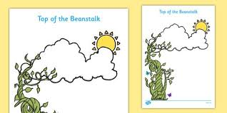 | Maths  Sing and Dance to Jack Hartman counting to 20 on  You Tube  Coin Hunt  Hide some of the Giant’s coins around the house and in the garden. Ask the children to find as many coins as they can in 5 minutes.  How many coins did you find?  What is the value of each coin?  Challenge  Add two coins together and record your jottings.  Example:  2p + 1p = 3p  •• • | Reading.  Read one of your Bug Club Books.  Bug club  Log On:  Username:  Password: bug  School ID-7ach  Please learn to read.  Phase 2 Tricky Words.  I, to, the, no, go, into  Once your child is confident at reading Phase 2 move onto Phase 3.  Phase 3 Tricky Words.  He, she, we, me, was, be, you, they, all, are, my, here.
Friday 15th January | P.E:  Go for a brisk walk.  OR try Mike The Cosmic Space Monkey | A Cosmic Kids Yoga Adventure!  https://www.youtube.com/watch?v=LZAaZDVqCiA | Phonics:  Read one of your Bug Club Books.  Bug club | English  Practice writing your name.  You can use:  •Chalk outside  •Water and a paintbrush on the patio.  •Paint  •Use your finger to write the letters in a tray of flour.  • Use a whiteboard and white board pen. | Maths  Practice writing numbers 1-10.  Use these rhymes to help you:-  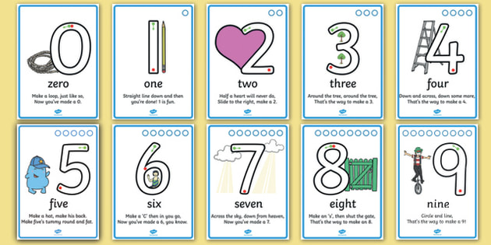  Now practise writing your numbers 11-20.  Number Rhymes | Fine Motor- Cutting  Allow children to develop their cutting skills by allowing them to cut up old Christmas cards, magazines or newspapers.  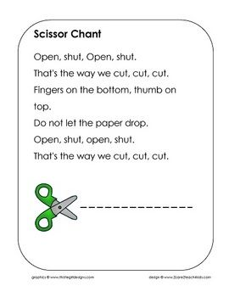

He'll Be Climbing
Up the Beanstalk
(Sing to the tune of 'She'll Be Coming Round the Mountain'.)
(This verse is about Jack)
He'll be climbing up the beanstalk when he comes.
He'll be climbing up the beanstalk when he comes.
He'll be climbing up the beanstalk, climbing up the beanstalk, Climbing up the beanstalk when he comes.
Singing ey, ey, yippee, yippee, ey.
Singing ey, ey, yippee, yippee, ey.
Singing ey, ey, yippee, ey, ey, yippee, Ey, ey, yippee, yippee ey.
(This verse is about the giant)
He'll be stomping round the castle when he comes.
He'll be stomping round the castle when he comes.
He'll be stomping round the castle, stomping round the castle, Stomping round the castle when he comes.
Singing fe fo fum here I come. Singing fe fo fum here I come. Singing fe fo fum, fe fo fum, Fe fo fum here I come.
(This verse is about Jack and the giant)
They'll be racing down the beanstalk when they come.
They'll be racing down the beanstalk when they come.
They'll be racing down the beanstalk, racing down the beanstalk, Racing down the beanstalk when they come.

